Application form for the 2017 Australian Seminar
The Seminar will consist of nine classes from the 14th to the 18th of April 2017
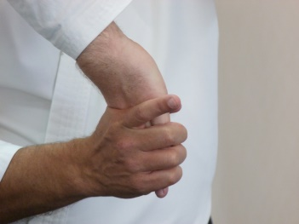 |  | 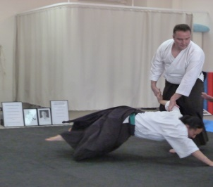

Please complete the form below  Name: …………………………………………………………………………. Club: …………………………………..  Number of classes attending: …………………………… Deposit of £35.00  (The cost of the Seminar is Aus$15.00 per class @ 9 classes = AUS$135.00 roughly £79.00) | Total  £ ………
Accommodation  We have organized a share house for the week that  - sleeps 15 people  - has a pool  - 5 minute walk from the beach  - 5 minute drive to the Dojo  The final cost of the Accommodation will depend on the amount of people who stay in the house  ( ie 15 people @ AUS$162.5 roughly £95.00. )  If you wish to stay in the share house there is limited spots and you will need to pay a  Deposit of £50.00  (If you are not interested in using this option please feel free to organize your own accommodation on the Sunshine Coast in Queensland.) | £ ………
Food  We are putting together a catered food package that will include breakfast, lunch and dinner. If you wish to be part of this you will need to pay a  Deposit of £50.00  Our estimation of the cost of the food is based on 3 meals a day over 6 days @ AUS$207.00 roughly £120.00  If you have any special needs with your diet please let us know………………………………………………………  ………………………………………………………………………………………………………………………………………………………..………….. | £ ………
Total | £ ……….

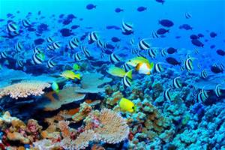 |  | 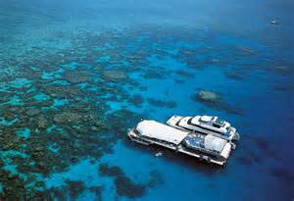

Extra Activities
Please tick the box to the right if you would like to be included in these activities
Australia Zoo
a half day trip during the five day Seminar up the Sunshine Coast

www.australiazoo.com.au

Draculas
on Wednesday night ( the 19th of April ) to end our Ozzie Seminar

www.draculas.com.au

Cairns
in North Queensland for a bit of R n R ( from the 20th to the 27th of April )

www.cairnsinfo.com
Payment  Please deposit your money into the account below with your name as our reference  Account name – S. Vickers  Bank – Halifax PLC  Account No – 01200480  Sort Code – 11-03-20 Total  Please forward these forms to  Adrian Smith – aan_smith@hotmail.com | £ …………..

